1- What is Cursor:

Hi everyone.
Today I want to introduce you to cursor AI, an innovative tool that is revolutionizing the way we write codes as artificial intelligence continues to shape our world.
Cursor AI emerges as a powerful assistant designed to enhance productivity, simplify coding tasks, and support developers in creating more efficient software solutions.

So what exactly is cursor AI?

============================= ==

Buit on the top of VS code – familiar environment with extra AI powers.
We can say vs code + ai = Cursor ai.
So vs code is open source it means all the code is on intenet, What cursor
People did they took all the code of vs code and apply the ai.

It is an AI powered code editor that integrates seamlessly with your development workflow.

Unlike traditional code editors, cursor AI provides intelligent code suggestions, automatic bug detection, and even generates complex code structures based on natural language prompts.

This means developers can spend less time debugging and more time focusing on building high quality applications.

One of the most remarkable features of cursor AI is its ability to understand context.
Access.

For example, if you are working on a Python project and need a function to process data, you can simply describe what you want and cursor. will generate a vast structures and efficient function for you.

It also helps in refactoring code, making it cleaner and more maintainable.
Moreover, cursor I is an excellent learning tool.

In summary, cursor AI is transforming software development by making coding smarter and more efficient.

Whether you are a beginner or experienced developer, this tool can significantly boost your productivity and coding experience.

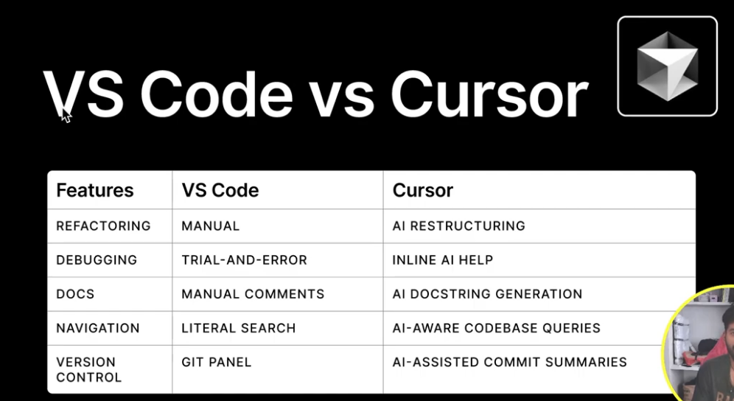

2: Installation of Cursor AI

How to Install and Set Up Cursor AI

Prerequisites

Before installing Cursor AI, ensure you have the following:

- A compatible operating system (Windows, macOS, or Linux)
- Node.js installed (recommended latest LTS version)
- Git installed
- An internet connection

Installation Steps

1. Download Cursor AI
Go to the official Cursor AI website and download the appropriate version for your operating system.

2. Install Cursor AI
For different OS, follow the installation steps below:

Windows:

- Open the downloaded .exe file.
- Follow the on-screen instructions to complete the installation.

macOS:

- Open the downloaded .dmg file.
- Drag and drop Cursor AI into the Applications folder.

Linux:

- Open the terminal.
- Run the following command:

  - sudo dpkg -i cursor-ai.deb # For Debian-based systems
  - sudo rpm -i cursor-ai.rpm # For Red Hat-based systems

Verify Installation

After installation, open a terminal or command prompt and run:

- cursor –version

If Cursor AI is installed correctly, you should see the version number.

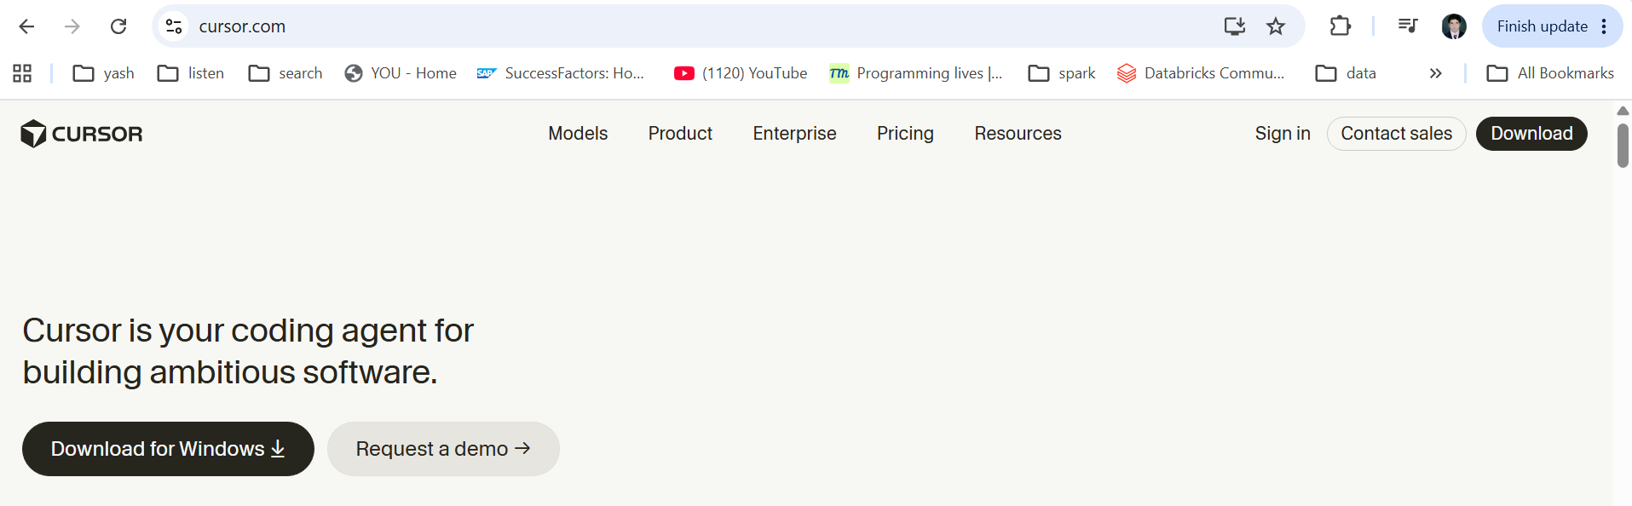
Accept the agrrement:
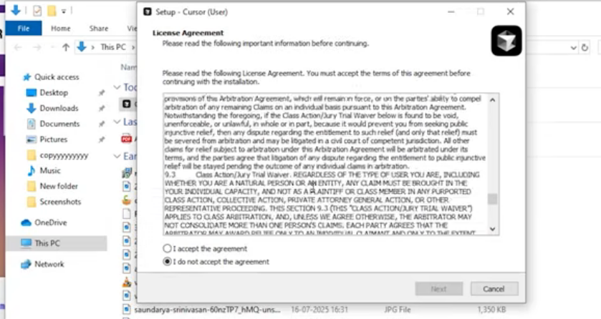
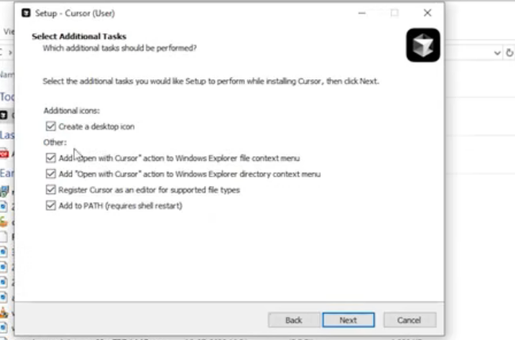
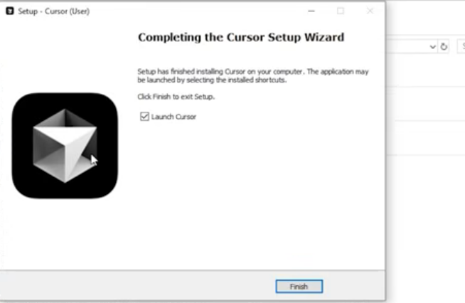

4. Set Up Cursor AI

- Open Cursor AI.
- Sign in or create an account.
- Follow the setup wizard to configure your preferences.
- Integrate Cursor AI with your preferred code editor (VS Code, JetBrains, etc.).

5. Test Cursor AI

To ensure everything works, open your code editor and start using Cursor AI for code suggestions and completions.

Conclusion

Congratulations! You have successfully installed and set up Cursor AI. Now, you can enhance your coding experience with AI-powered assistance. Happy coding!

- Open the cursor
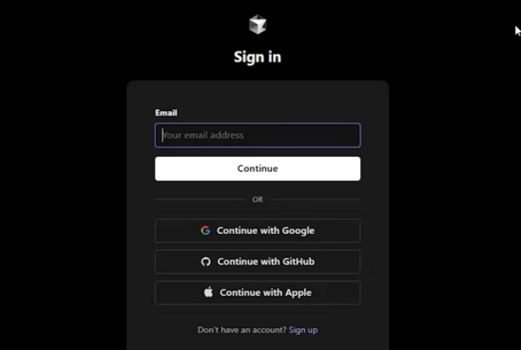
After login it will redirect to this page:

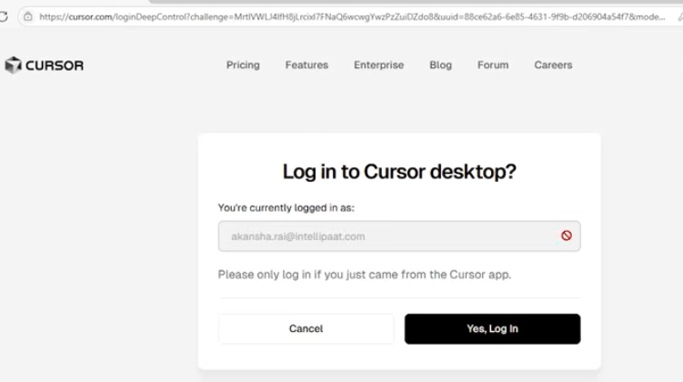

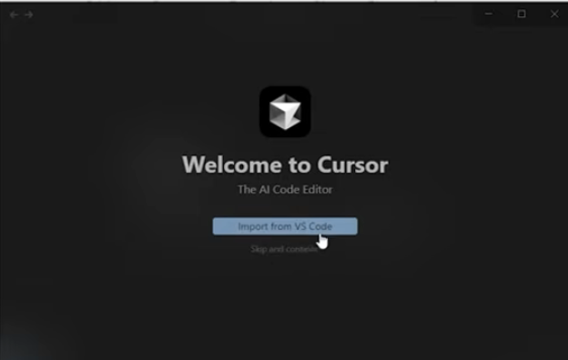
- After downloaf when you open the cursor ai – I will see this interface.

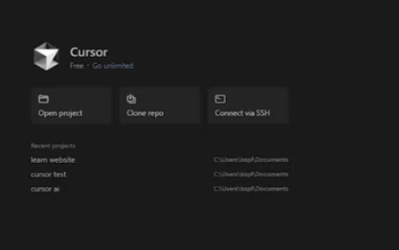

When I open the cursor there is 3 menu-
- Open project
- Clone repo
- Conenct with SSH
1. Open Project 📂 (Open code already on your laptop.)
Purpose: Open a project that already exists on your local machine.
Example:
- You have a Python project in:
- D:\Projects\EmployeeManagement
- Click Open Project → Select the folder.
- Cursor loads all files and starts AI assistance.
Use Case: Working on an existing local project.

2. Clone Repo 🔄 (Download code from GitHub/Azure DevOps.)
Purpose: Download a project directly from GitHub, Azure DevOps, or GitLab.
Example: Repository:
Plain Text
1
https://github.com/arunlal/python-training.git
Show more lines
Steps:
- Click Clone Repo
- Paste the repository URL
- Choose a local folder
- Cursor downloads the code
Use Case: When the code is stored in a remote Git repository.

3. Connect with SSH 🌐 (Work directly on a remote server.)
Purpose: Connect to a remote server and work on code stored there.
Example:
Plain Text
1
Server: 10.10.10.100
2
User: ubuntu
3

Show more lines
Steps:
- Click Connect with SSH
- Enter server details
- Connect to the remote machine
- Edit and run code directly on the server
Use Case: Working on Linux servers, cloud VMs, or production environments without copying code locally.

4: Cursor Settings
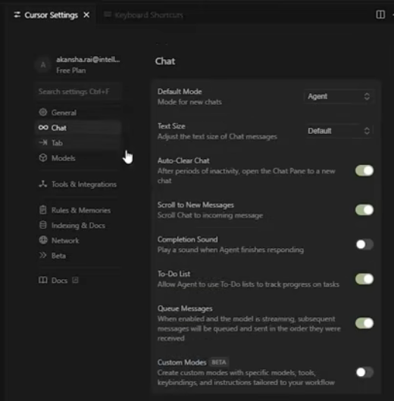

1- We have chat tab.

